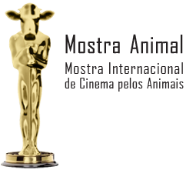
Exhibition Authorization Document for the film submission to the
MOSTRA INTERNACIONAL DE CINEMA PELOS ANIMAIS
(International Film Festival for the Animals)

By completing and signing this document, and sending your film, you are agreeing to the Mostra Animal Regulation’s terms.

( ) I have read and accepted all the terms of the Regulation for the “Mostra Internacional de Cinema pelos Animais” (International Film Festival for the Animals).

I authorize the Sociedade Vegetariana Brasileira (Brazilian Vegetarian Society) to exhibit the aforenamed film in the travelling editions of the International Film Festival for the Animals. This authorization may be revoked by the producer at any time after notice of 30 days.
( ) Yes ( ) No

_______________________________________
City and Date

_______________________________________
Signature of the person who is responsible for the film

